**Database Management System**

**Title: Hospital Management System**

**Group members:**

|  |  |  |
| --- | --- | --- |
| **Name** | **G.R. no** | **Roll no** |
| Bobade Shubhjit Vilas | 22020180 | 231075 |
| Shaikh Asif dagadu | 22020288 | 231079 |
| Munde Ram Madhukar | 22020086 | 231073 |
| Ganji Prashant Tukaram | 22020246 | 231077 |

**Guided by:**

Mrs. .

# **INTRODUCTION**

The purpose of the project entitled as “HOSPITAL MANAGEMENT SYSTEM” is to computerize the Front Office Management of Hospital to develop software which is user friendly simple, fast, and cost-effective. It deals with the collection of patient’s information, diagnosis details, etc. Traditionally, it was done manually. The main function of the system is register and store patient details and doctor details and retrieve these details as and when required, and also to manipulate these details meaningfully System input contains patient details, diagnosis details, while system output is to get these details on to the screen. The Hospital Management System can be entered using a username and password. It is accessible either by an administrator or receptionist. Only they can add data into the database. The data can be retrieved easily. The data are well protected for personal use and makes the data processing very fast.

**SOFTWARE REQUIREMENTS**

|  |  |
| --- | --- |
| Language | PHP, JavaScript |
| Database | MYSQL |
| Software development kit | XAMPP server, VS code |

**LITERATURE SURVEY**

Hospital Management System is a computerized medical information system that collects, stores and displays patient information. It deals with drug, equipment, human resources and other relevant information. They are a means to create legible and organized patient data and to access clinical information about individual patients. Automated hospital management systems are intended to complement existing (often paper based) medical records which are already familiar to practitioners. Patient records have been stored in paper form for centuries and, over this period of time; they have consumed increasing space and notably delayed access to efficient medical care. In contrast, automated hospital management system stores individual patient clinical information electronically and enable instant availability of this information to all providers in the healthcare chain and so assist in providing coherent and consistent care. The advantages hospital management system can be summarized according to as "optimizing the documentation of patient encounters, improving communication of information to physicians, improving access to patient medical information, reduction of errors, optimizing billing and improving reimbursement for services, forming a data repository for research and quality improvement, and reduction of paper". The health care sector is an area of social and economic interest in several countries; therefore, there have been lots of efforts in the use of electronic health records. Nevertheless, there is evidence suggesting that these systems have not been adopted as expected, and although there are some proposals to support their adoption, the proposed support is not by means of information and 23 communication technology which can provide automatic tools of support.

**DATABASE CONCEPT USED**

* create
* Insert
* Update
* Delete
* Primary keys
* Auto increment for table
* commit

**GETTING INTO THE PROJECT**

Hospital Management System in php and MySQL. This system has a ‘Home’ page from where the patient, doctor & administrator can login into their accounts by toggling the tabs accordingly.

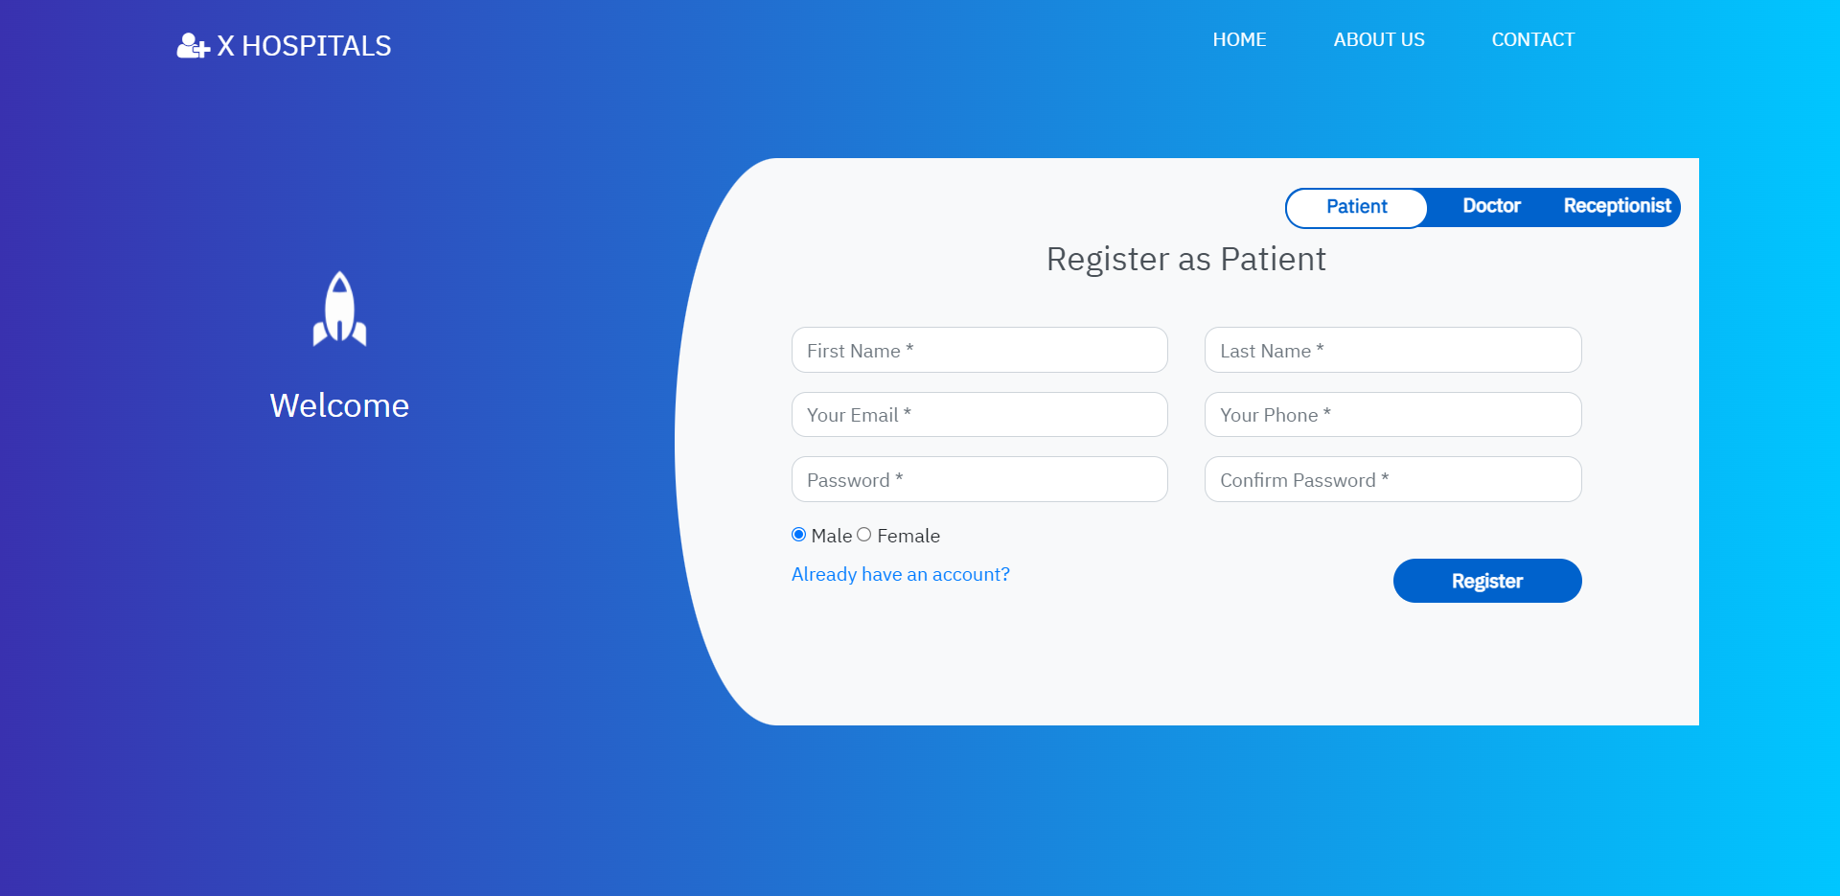

'About us' allows us to get some more information about the quality and the services of the hospital.



‘Contact’ page allows users to provide feedback or queries about the services of the hospital.

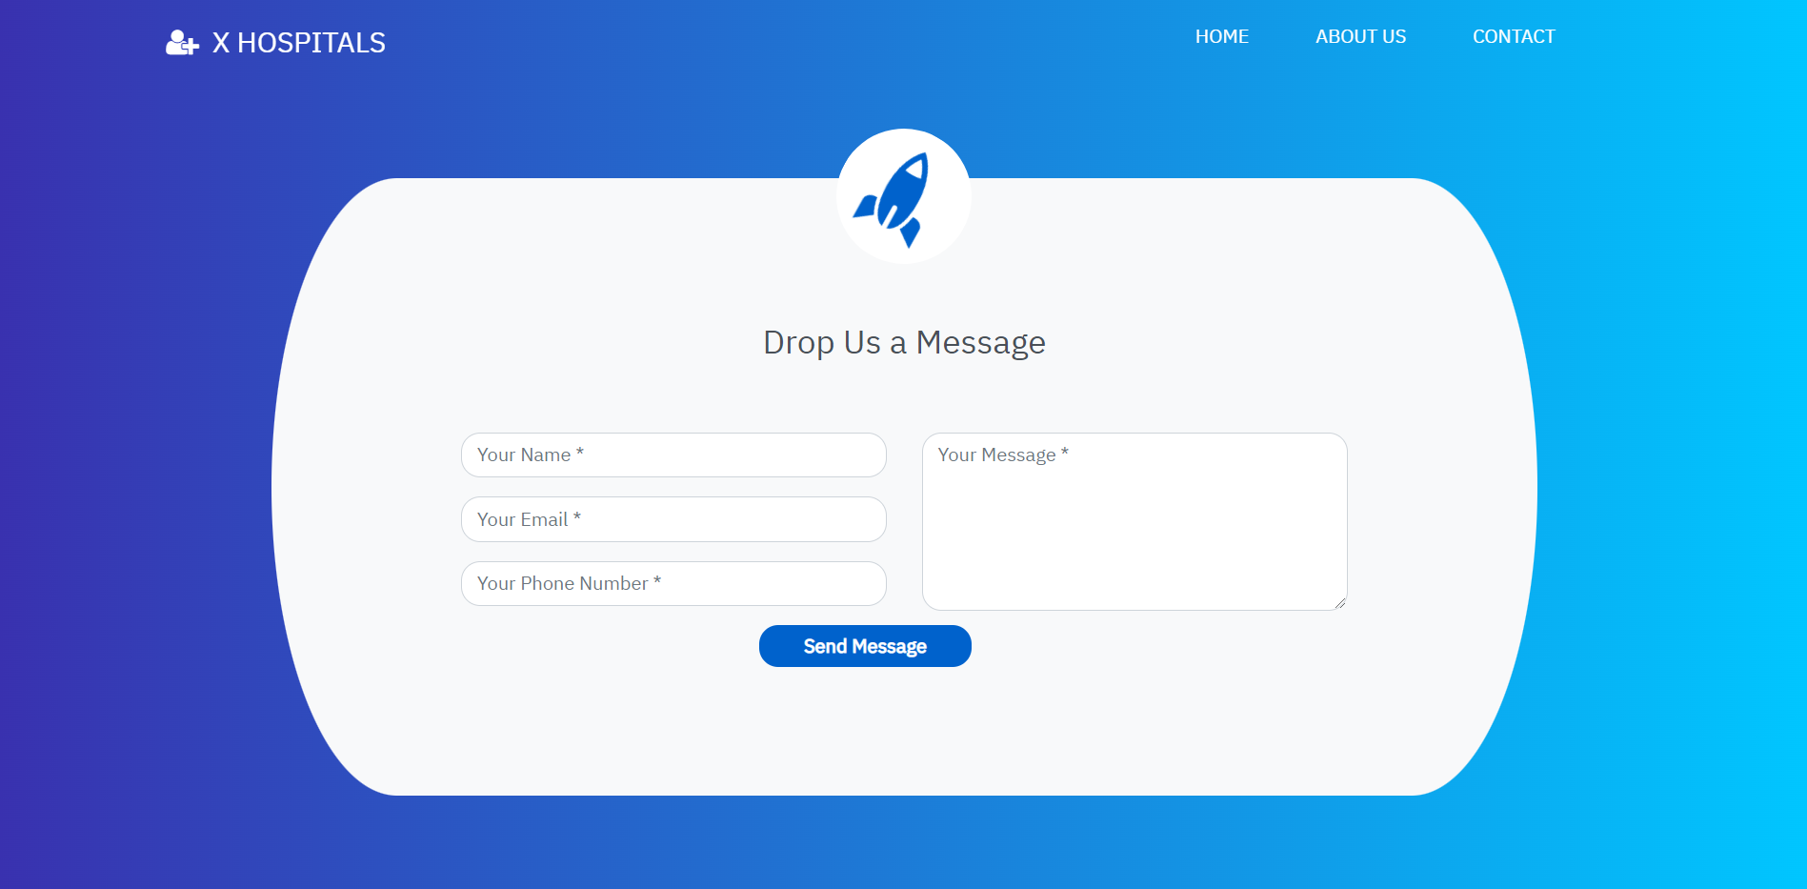

The ‘Home’ page consists of 3 modules:

1. Patient Module

2. Doctor Module

3. Admin Module

**Patient Module**

This module allows patients to create their account, book an appointment to see a doctor and see their appointment history.

The registration page (in the home page itself) asks patients to enter their First Name, Last Name, Email ID, Contact Number, and Password and radio buttons to select their gender.

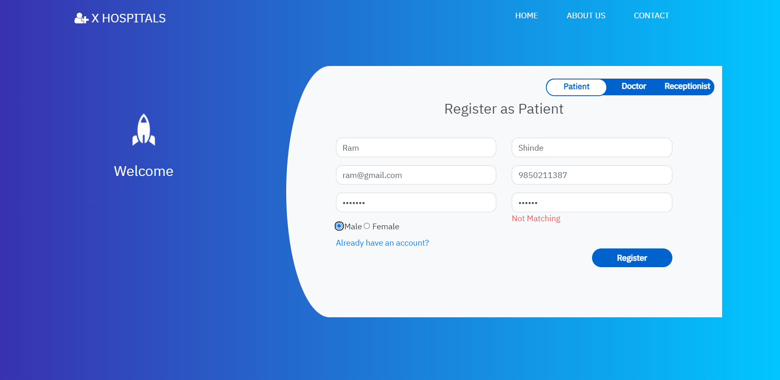

Once the patient has created his/her own account after clicking the ‘Register’ button, then he will be redirected to his/her Dashboard

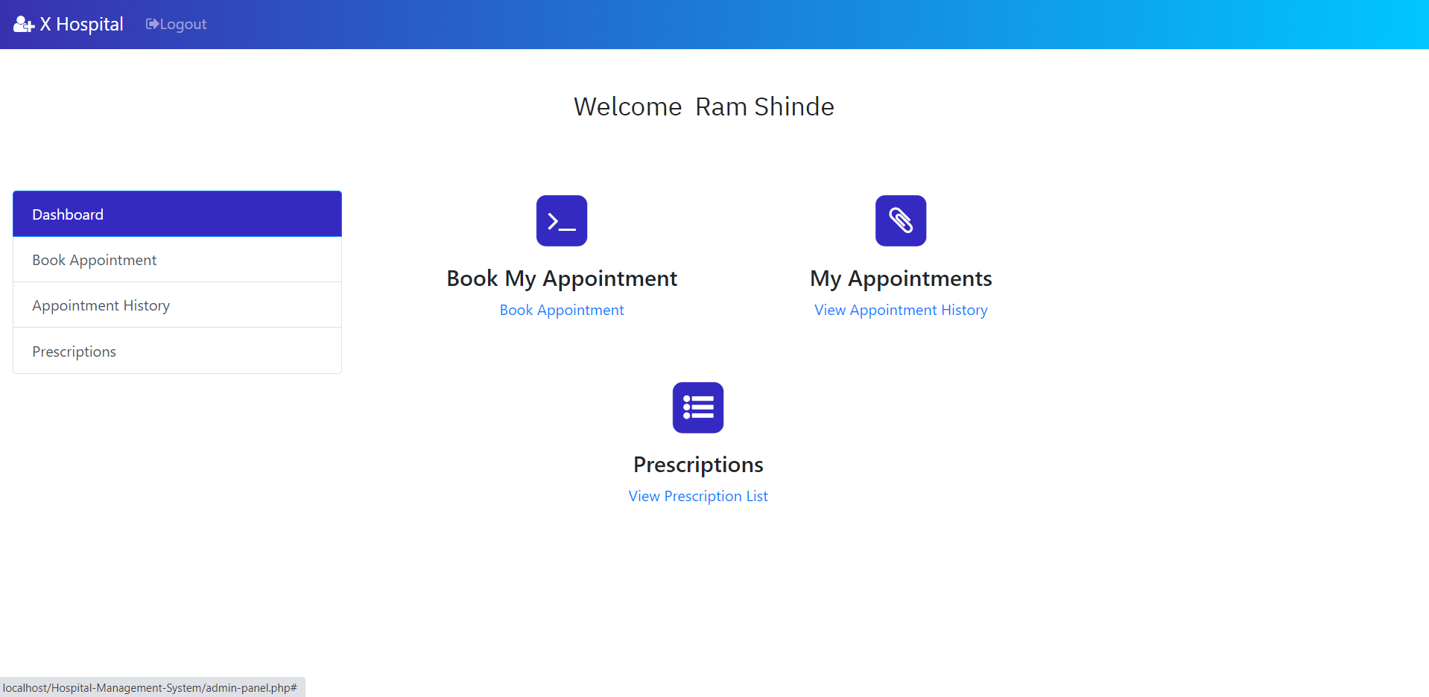

The Dashboard page allows patients to perform two operations:

**1. Book his/her appointment**

Here, the patients can able to book their appointments to see a doctor. The appointment form requires patients to select the doctor that they want to see, Date and Time that they want to meet with the doctor. The consultancy fee will be shown accordingly to the patient as it was already determined by the doctor.

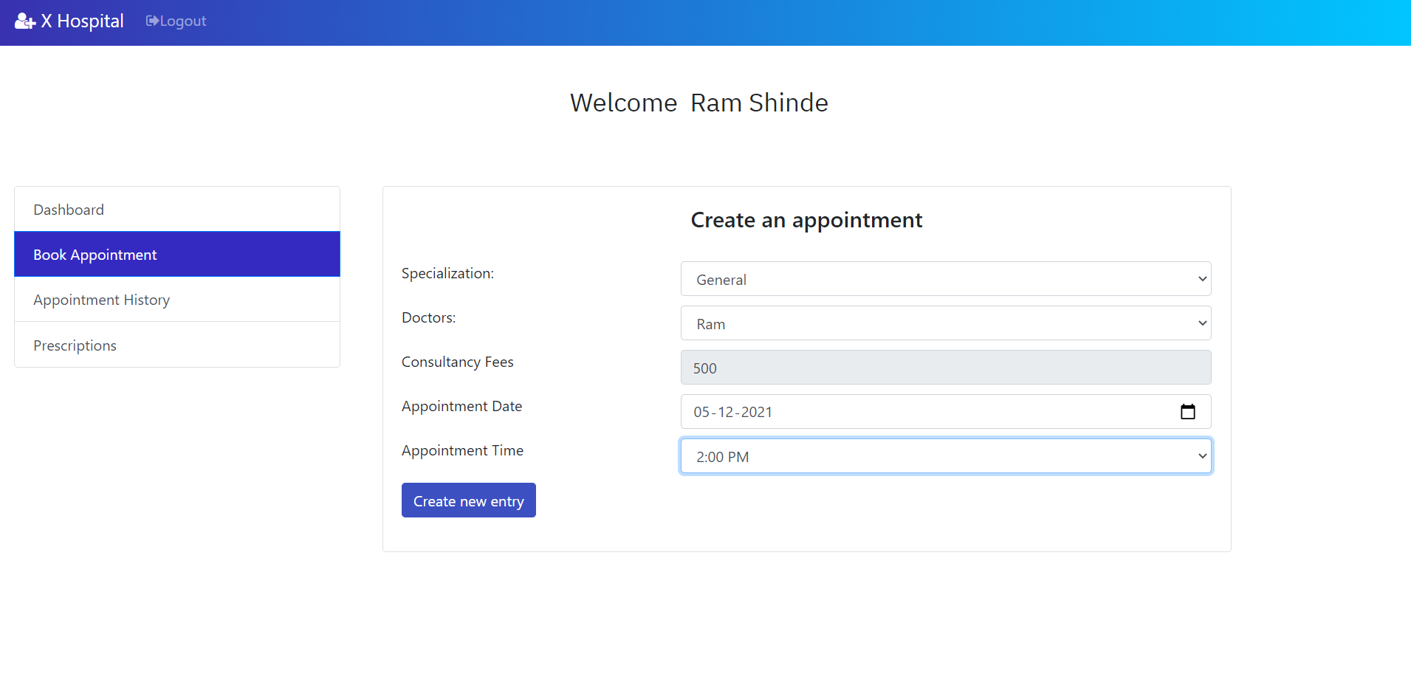

After clicking on the ‘Create new entry’ button, the patient will receive an alert that acknowledges the successful appointment of the patient.

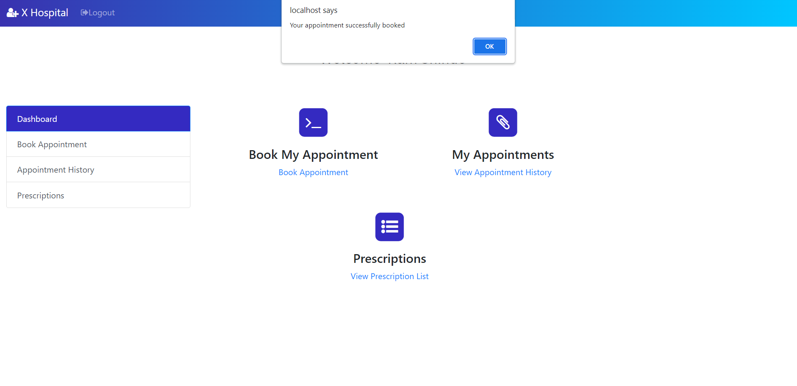

**2. View patients’ Appointment History**

Here, the patient can see their appointment history which contains Doctor Name, Consultancy Fee, Appointment Date, Time and Action. Patients can able to delete their appointments.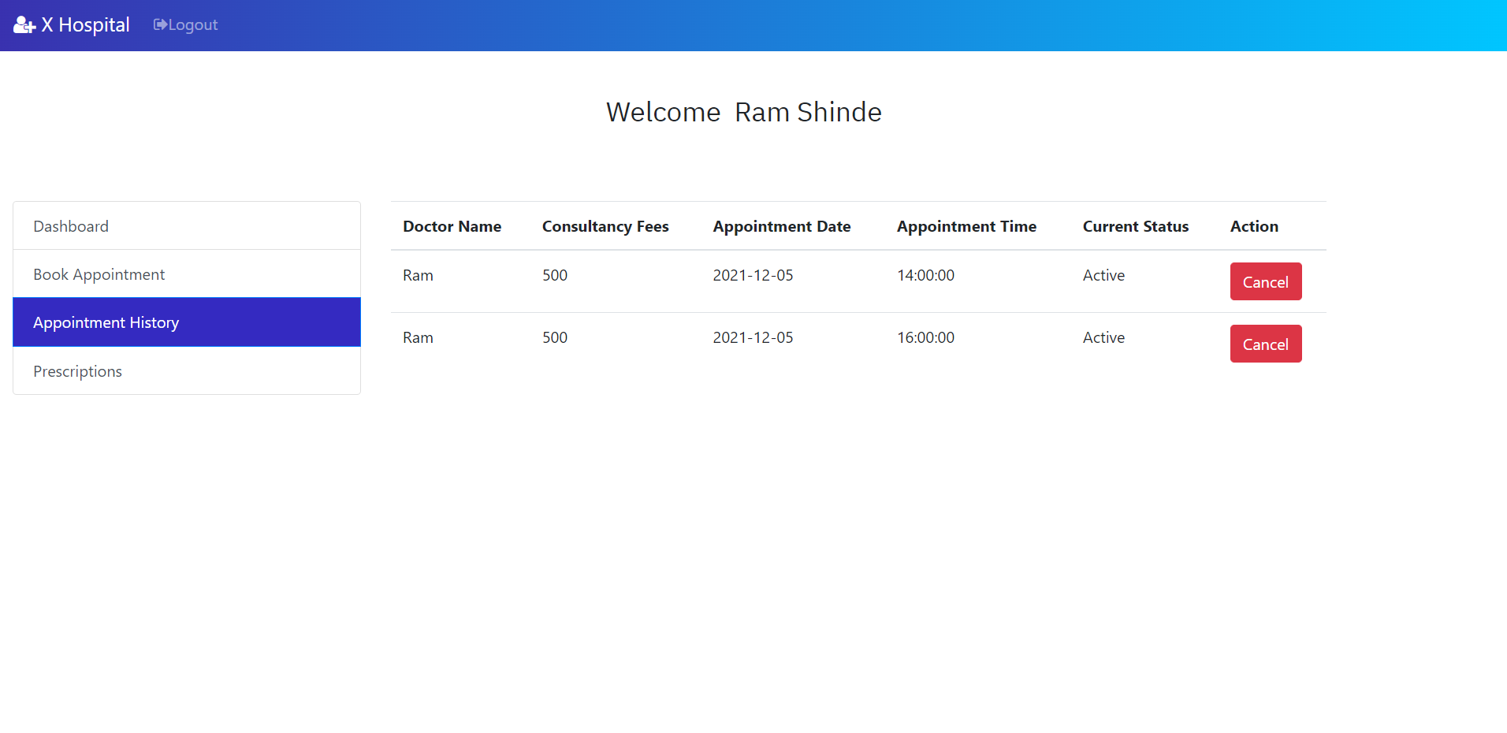

If the patient deletes the last record (for doctor Ganesh), then a label "deleted by you" will be displayed in the column 'Current Status' and the action will change to cancel state.

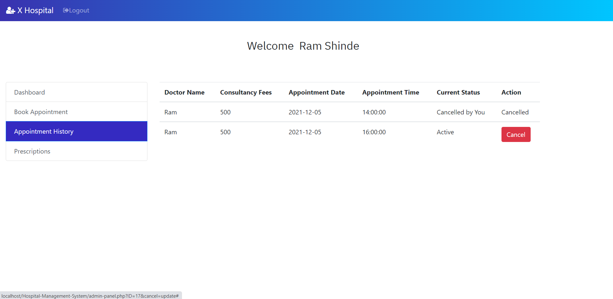

Once the patient has logged out of his account, if he wants to go into his account again, he can login his account, instead of register his account again. Clicking on ‘Login’ button will redirect the patient to his dashboard page which we have seen earlier

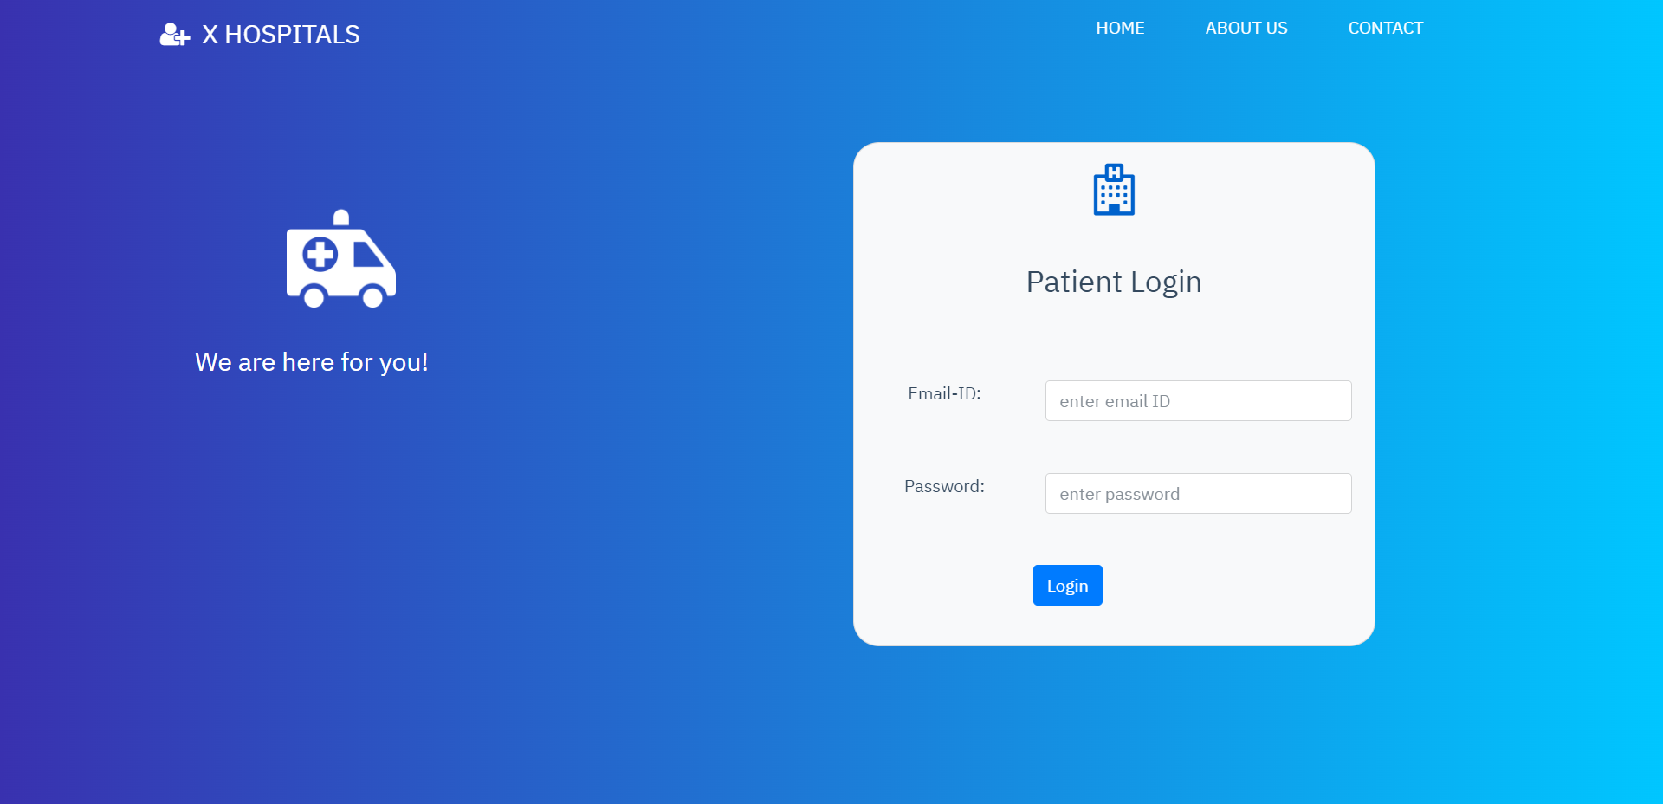

This is how the patient module works. On the whole, this module allows patients to register their account or login their account (if he/she has one), book an appointment and view his/her appointment history and also view there Prescription list.

**Doctor Module**

The doctors can login into their account which can be done by toggling the tab from ‘Patient’ to ‘Doctor’. Shows the login form for a doctor. Registration of a doctor account can be done only by admin. We will discuss more about this in Admin Module.

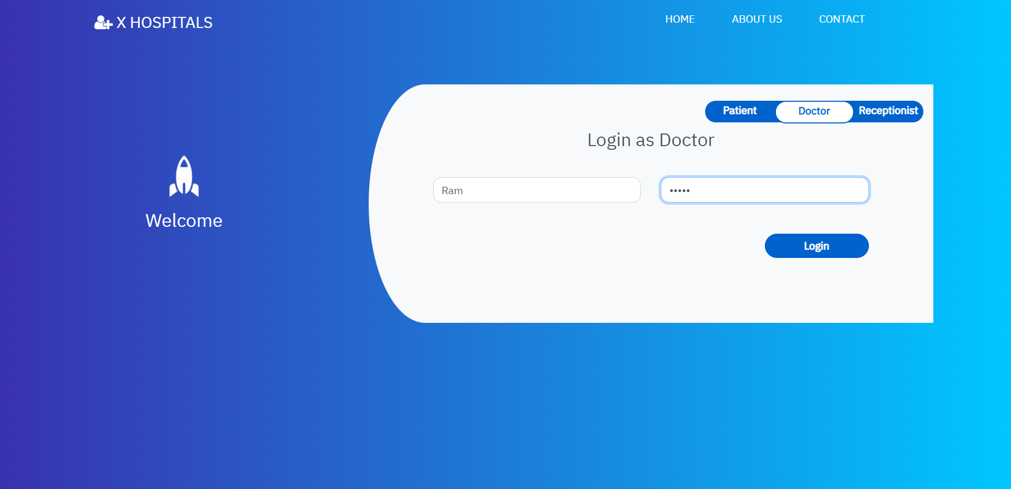

Once the doctor clicking the ‘Login’ button, they will be redirected to their own dashboard

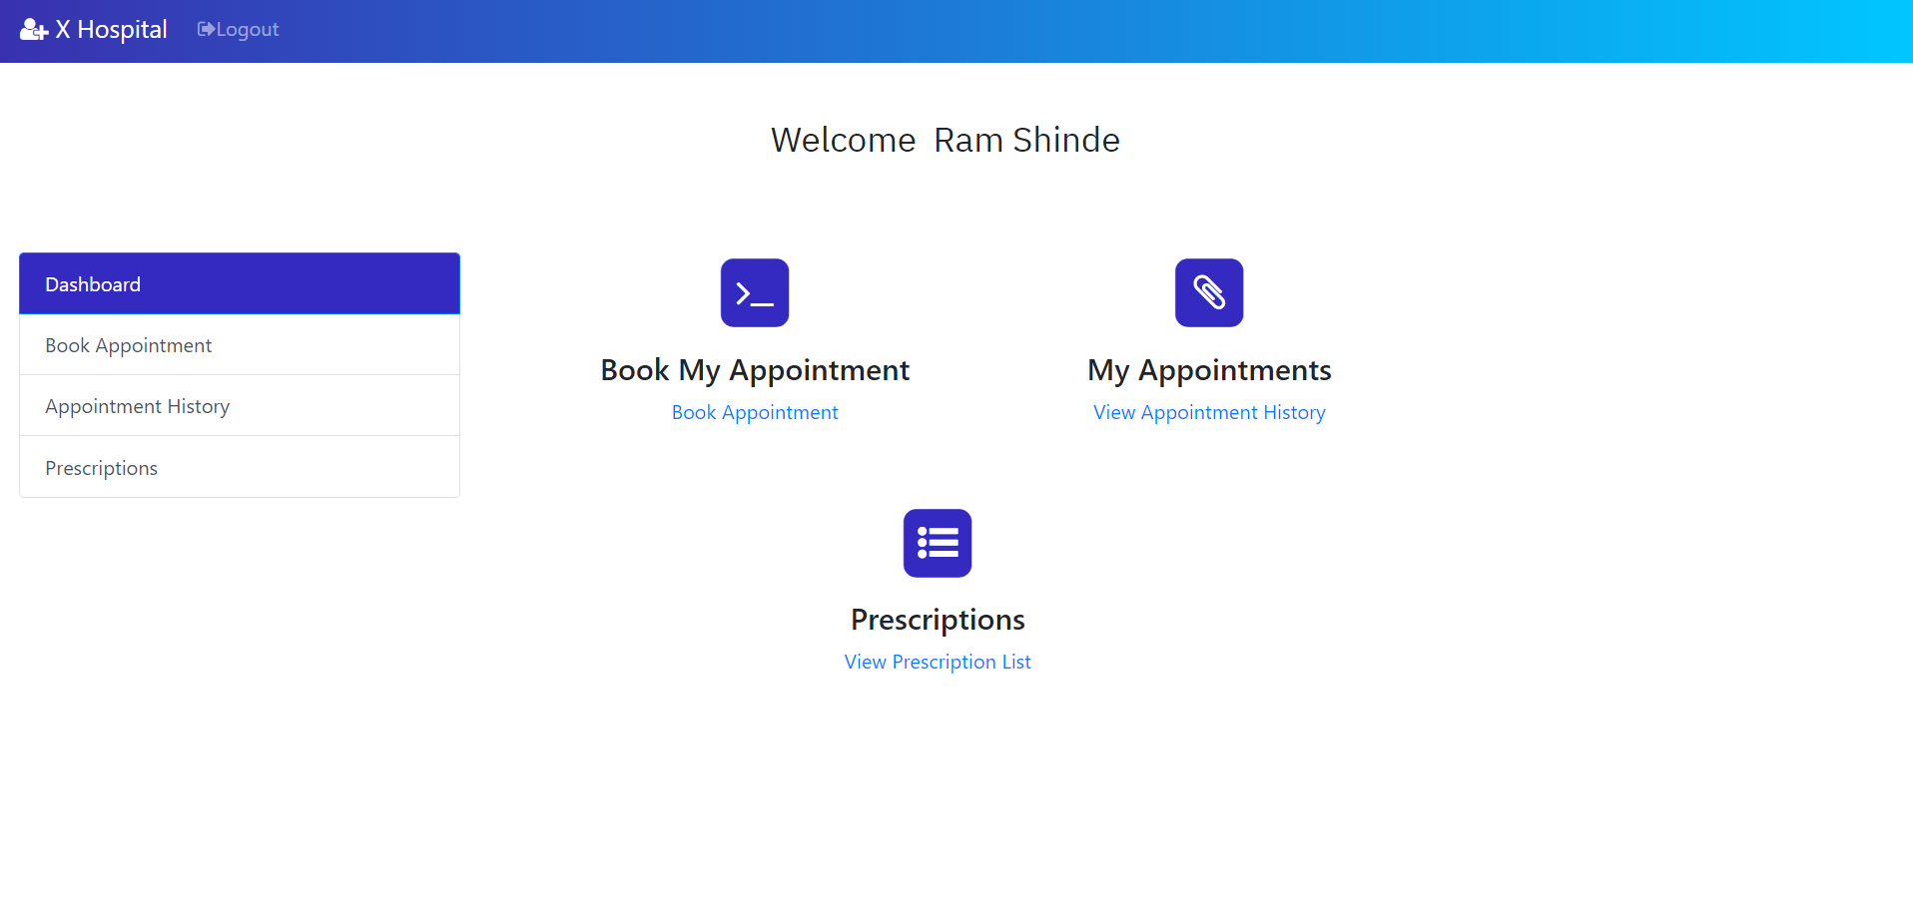

In this page, doctor can able to see their appointments which has been booked by the patients.

In real-time, the doctors will have thousands of appointments. It will be easier for a doctor to search for appointment in the case of more appointments. To make it easier, I have a ‘Search’ box in the navigation bar which allows doctors to search for a patient by their contact number.

Once everything is done, the doctor can logout of their account. Thus, in general, a doctor can login into his/her account, view their appointments and search for a patient. This is all about Doctor Module.

**Admin Module:**

This module is the heart of our project where an admin can see the list of all patients. Doctors and appointments and the feedback/queries received from the ‘Contact’ page. Also admin can add doctor too.

Login into admin account can be done by toggling into admin tab of the Home page.

`Username`: admin, `password`: admin123

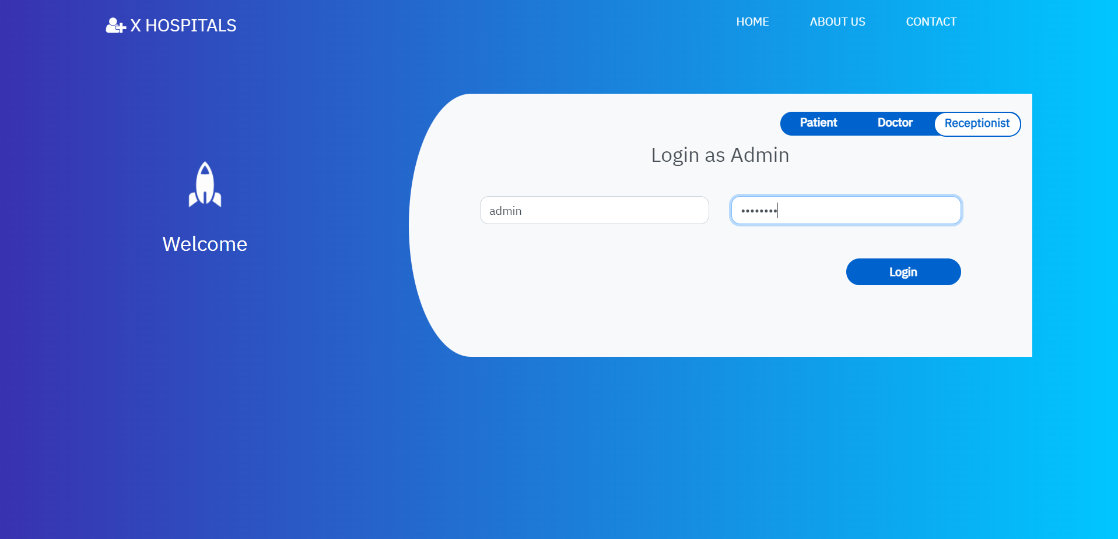

On clicking the ‘Login’ button, the admin will be redirected to his/her dashboard

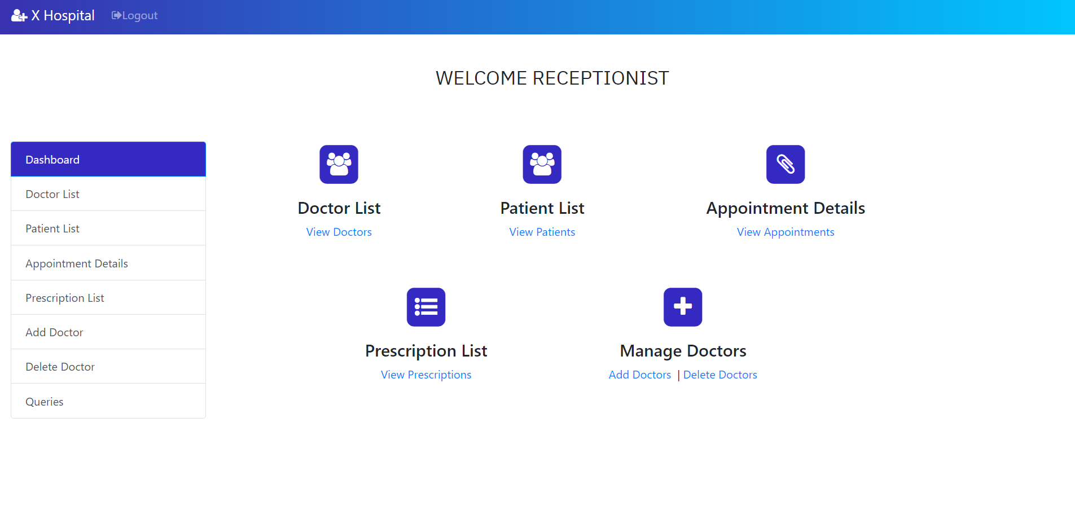

This module allows admin to perform five major operations:

**1. View the list of all patients registered:**

Admin can able to view all the patients registered. This includes the patients’ First Name, Last Name, Email ID, Contact Number and Password. (See Fig 1.15).As like in doctor module, admin can also search for a patient by their contact number in the search box.

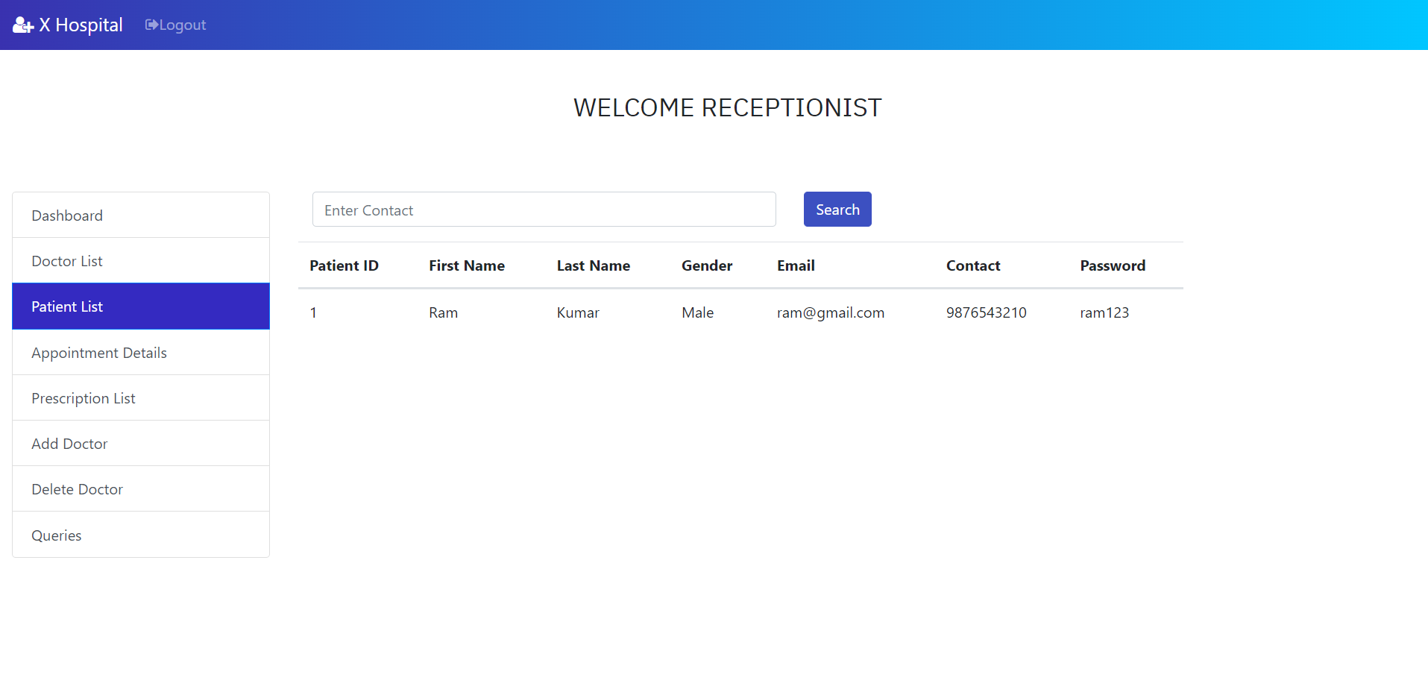

**2. View the list of all doctors registered:**

Details of the doctors can also be viewed by the admin. This details include the Name of the doctor, Password, Email and Consultancy fees, searching for a doctor can be done by using the doctor’s Email ID in the search box.

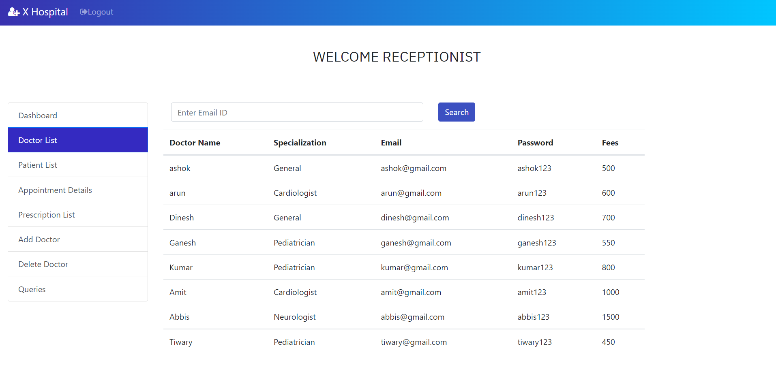

**3. View the Appointment lists:**

Admin can also able to see the entire details of the appointment that shows the appointment details of the patients with their respective doctors. This includes the First Name, Last Name, Email and Contact Number of patients, doctor’s name, Appointment Date, Time and the Consultancy Fees.

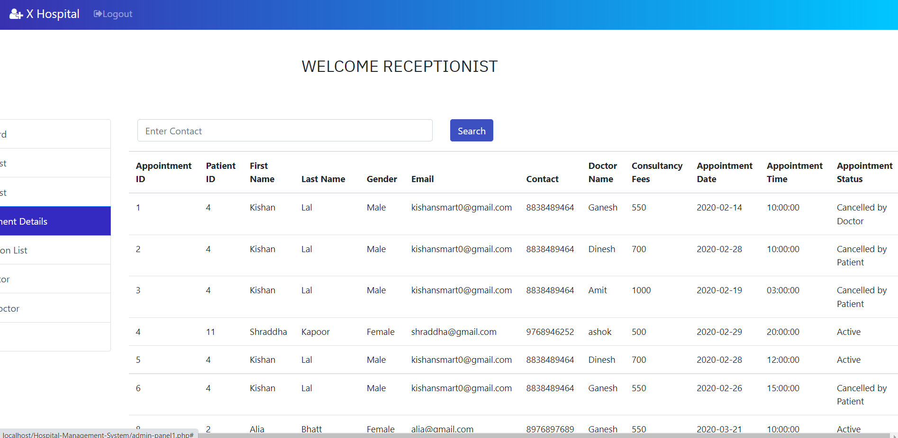

**4. Add Doctor:**

Admin alone can add a new doctor since anyone can register as a doctor if we put this section on the home page. This form asks Doctor’s Name, Email ID, Password and his/her Consultancy Fees.

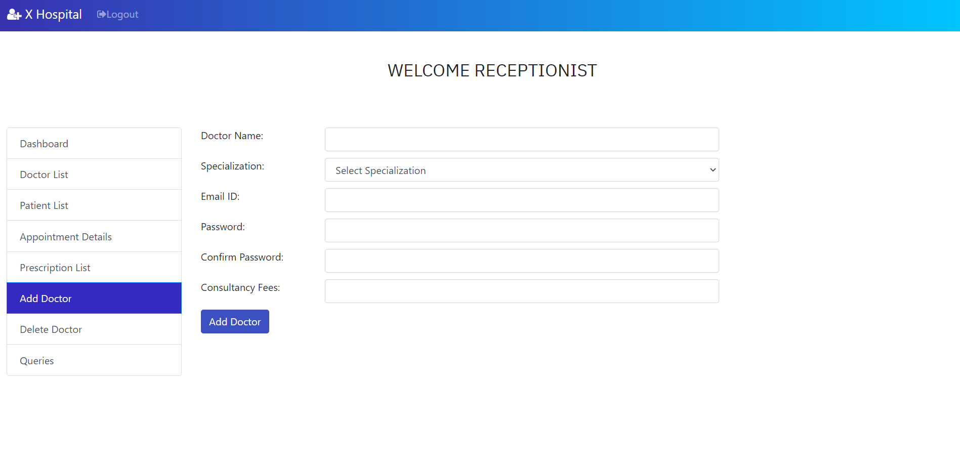

After adding a new doctor, if we check the doctor’s list, we will see the details of new doctor is added to the list

**5. View User’s feedback/Queries:**

Admin is allowed to view the feedback/Query that has been given by the user in the ‘Contact’ page This includes User’s Name, Email Id, Contact Number and the message(Feedback/ Query) 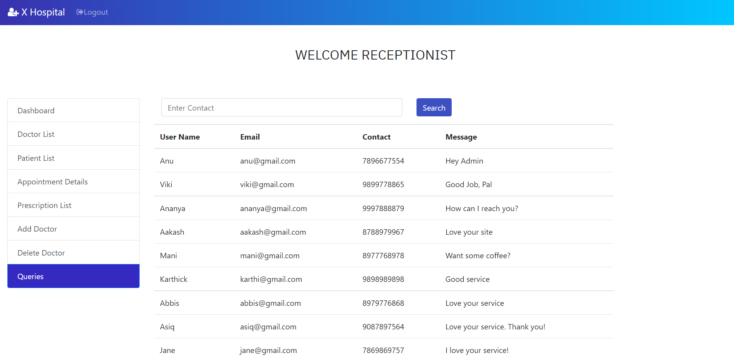

Taking everything into consideration, admin can able to view the details of patients and doctors, appointment details, Feedback by the user and can add a new doctor. Once everything is done, the admin can logout from his account.

**REFERENCES**

[1] Herbert Scheldt, Java Complete Reference, Fifth Edition, Tata McGraw Hill Edition.

[2] Phil Hanna, JSP 2.0: The Complete Reference, Tata McGraw Hill Edition, 2003.

[3] Elmarsi and Navathe, Fundamentals of Database System (Third Edition), Addision Wesley. [4] Ian Somerville, Software Engineering, Third Edition, Pearson Education.

[5] Ali Bahrami, Object-Oriented System Development, Third Edition, Tata McGraw Hill Edition

s